**Mental Health Warrants – During Court Hours**

**Applications in the South East Region of HMCTS**

(This protocol covers applications made by agencies covering the counties of Surrey, Sussex, Kent, Thames Valley, Kent, Essex, Cambridgeshire, Bedfordshire, Hertfordshire, Norfolk and Suffolk).

**Guidance Mental Health**

**Introduction**

This guidance is produced to assist Mental Health agencies, in conjunction with HMCTS, to effectively manage the efficient and effective administration of warrant applications made by Mental Health across the South East Region. This guidance should be read and followed in conjunction with the following documents:-

* The step-by-step guide for using the scheme is at page 3
* Team Up Guidance for booking slot for application is at page 8
* “out of Hours” warrant scheme
* Police Guidance when applying for a Court issued Search Warrant page 6

**Background to the scheme**

A HMCTS project team was established to investigate whether a Monday to Friday daytime regional search warrants scheme, complementing the out-of-hours scheme, could have positive benefits to both applicants and HMCTS. At present, in many locations across the South East Region, police officers and other agencies contact local court houses when they wish to make an application for a warrant. Sometimes courts are able to accommodate warrant applications immediately but at other times applicants are kept waiting until there is an appropriate break in the court list or proceedings, and on occasions, they are asked to attend the following day or make their application to the “out of hours” scheme. Sometimes, particularly if late in the day, access to a Justice of the Peace (JP) can be difficult and delay is again caused to the applicant whilst arrangements are made for the application to be heard. Diverting such applications into court lists disrupts the efficient processing of court business and even where the applicant does not experience a delay, other court users are often kept waiting, whilst the legal adviser and a JP consider the warrant application.

**Scheme overview**

The scheme will operate across the South East Region rotating across courthouses with police officers and other agencies making their applications by telephone and paperwork being received and dispatched by secure email.

The scheme will use a web based booking system. Police officers and other agencies will be using a web-based calendar to book in their applications on a date and time convenient to them. Officers can access the calendar 24 hours a day. Applications will be considered between 10.00am and 4.30pm.

Applications, warrants granted, and reasons for grant/refusal will be stored securely in an electronic pdf format or password protected within a designated folder. Hard copies of the paperwork will therefore be easily accessible to HMCTS should there be a requirement to produce it at a future date. The electronic storage system will ensure that storage of the relevant information complies with data security and retention timescales. Only authorised personnel will have access to the secure email box and storage facility.

Legal advisers will be responsible for ensuring the relevant paperwork is both received and dispatched in good order in accordance with the guidance and that all information is correctly stored and filed.

Applications will be initially scrutinised by a legal adviser who will then provide advice on matters of law, practice and procedure to the relevant Justice of the Peace, who will be rostered to consider such applications on any particular day.

This scheme envisages that all warrants will be considered under this scheme unless the scheme is unable to respond quickly enough to an urgent application or the volume of warrants is such that diversion to a location court site is preferable. This scheme will operate in conjunction with and to complement the “out of hours” search warrant scheme (which will apply after 6pm).

**Benefits of the scheme**

It is envisaged that the scheme will:-

* Ensure that warrant applications, including urgent applications, are considered in a timely manner in accordance with the law and best practice;
* Enable the very vast majority of applications to be considered without disruption to the efficient processing of other court business;
* Provide an enhanced customer service to police forces and other agencies within working hours and reduce both the uncertainty and delay that can be experienced when arranging to make a warrant application;
* Make best use of police, other agency’s, legal adviser and judicial time;
* Make best use of HMCTS estate by removing such applications from courtrooms; and
* Reduce the administrative tasks surrounding the processing, filing and storage of such applications by making best use of electronic and digital solutions.

**Procedure and guidance for the police officers and other authorised applicants wishing to apply for a warrant.**

**Applications for warrants where the application is to be made during the working hours of 10.00 am to 4.30pm**

1. **Making a booking:** Book in your application using the web-based Team Up calendar. Bookings can be made at anytime as the calendar is available 24 hours a day, 7 days a week.
2. The Team up Calendar can be accessed by pasting the following link into your internet browser.

<https://teamup.com/ks6690746618bf280f>

See Team up Guidance for assistance

1. **When you can book a hearing:** Officers and other authorised applicants can choose the date and time of their application hearing from the available time slots on the calendar. There is additional guidance for multiple applications. Bookings can be made on the day you wish the application to be heard if there is space available and the time slot has not passed. It is feasible therefore that applications can be made on the same day as the application is to be heard if there is hearing time available in the calendar. Officers and agency staff are encouraged however (where practicable) to book in advance thus helping the court to effectively manage applications and incorporate urgent applications at short notice. Ensure that the correct slot duration is booked. When booking applicants will need to amend the booking time so only 15 mins is booked. If this is not amended a one hour slot will automatically be booked which blocks the slots for other prospective applicants.
2. Using the guidance obtain your booking code and ensure this is recorded on the calendar at the time your booking is made, the date within the booking code is the date the application is to be heard; for example **MH01.12.151Blue.** It is imperative that you do not include any personal details about the warrant on the Team Up calendar as the calendar is not on a secure website. It is also best practice not to include any information which could identify that this is a police and agency calendar i.e. station or police name/ collar number or that it is a warrant application.
3. **Submitting applications:** All relevant paperwork must be submitted at the time the booking is made to the secure email box. The correct applications and warrants are attached to the last page of this guidance. Please name your documents to include the booking reference and not the address of the premises.

[**SouthEastSearchWar@hmcts.gsi.gov.uk**](mailto:SouthEastSearchWar@hmcts.gsi.gov.uk)

An automated response will be sent from the above email address when an email has successfully been received. If you do not receive this automated response, your email has not been received therefore please check the address for errors.

Bookings for which no relevant paperwork is submitted will not be accommodated by the court.

1. **Multiple Warrants:** Applicants should specifically note the guidance on booking multiple warrants as contained in the Team Up Guidance.
2. Submit the application and draft warrant to the secure HMCTS email box (below). For Mental Health/Civil applications you must also provide proof of payment of the fee, (current fee is £75), and a scan of your authorisation badge/lanyard. It is anticipated that most agencies will be set up to pay by account, to arrange this please contact EAU It Support on 0203 334 6248. Card payments for Cambs, Essex, Norfolk, Suffolk, Kent, Surrey and Sussex can be made by phoning Lowestoft on 01502 528211. For card payments for Beds, Herts and Thames Valley please phone Stevenage on 01438 344498. Please obtain the reference number as you will need to enter your payment reference on the warrant information. Where payment in advance has not been possible you will need to provide reasons as to why and complete an Undertaking to Pay form (attached on p16). Only in unusual circumstances will an undertaking to pay the fee be considered acceptable; payment in advance is expected. The application and warrant **must** be sent in Word format as the warrant will be endorsed electronically by the Magistrate/ legal adviser. Please remember all documents submitted need to have the booking reference in the name.
3. Check that the correct booking code has been used on all paperwork and that you have supplied your contact phone number details. This is the telephone number on which the court will contact you at the application hearing time.
4. Check that the paperwork has been submitted from a secure email address. This is the email address that the court will return your electronically signed warrant if granted and/or reasons for the grant/refusal of the application.
5. If the applicant is submitting the application on behalf of another person, their email address must be included on the application and cc’d in when the application is sent to the inbox. Both email addresses must be secure email addresses.
6. Check that only the booking code appears in the subject heading of the email for example **MH01.12.151Blue. Please do not include any other information in the subject header other than the booking code.**

* **The secure email box can be accessed at SouthEastSearchWar@hmcts.gsi.gov.uk**

Only legal advisers approved to support the regional duty search warrant scheme by their Justices’ Clerks will have access to the secure email box.

Where paperwork or information is missing, including the booking code, the duty legal adviser will contact you, at the earliest opportunity, and no later than the application hearing time, by phone or email. You will be advised to re book your application and re-submit your paperwork.

Whilst every effort will be made to give the applicant as much notice as possible that their application will not be considered due to paperwork error, it is the responsibility of police officers and other authorised applicants to ensure that their paperwork complies with the requirements of the scheme by submitting the correctly headed documents and in Word format.

1. **Making the application:** At the designated application hearing time you will be contacted by the court and asked to verify your identity. You should be able to provide:-
   1. Booking code;
   2. Force/Agency applying;
   3. Details of the authorising inspector (if police application)
   4. Details of your authorisation badge/lanyard (if Mental Health/Civil application)
2. If the court is satisfied that they are speaking to the applicant, you will be asked to take the oath/affirm and make your application. You will need to provide your own holy book should you wish to use one. You must be ready with the oath/ affirmation at the time of your booking.

The oath / affirmation is found at page 6.

1. It is important that applicants are at an appropriate secure location to receive the court’s call as it will not be possible to delay the application in order to facilitate the applicant moving to another location, to ensure that the information they will provide cannot be overheard.
2. Applications should then be considered in the normal way as if you, the applicant, were present in the room.
3. Please note the time limit on Mental Health warrants is 3 months, these warrants can only be used for a single occasion.
4. **Receiving the authorised warrant:** Once considered the warrant will be electronically signed by the JP where granted. Supporting reasons for grant/refusal will be endorsed on the relevant paperwork and returned to the applicant electronically as a locked document or pdf, to prevent any subsequent amendments. Paperwork will only be dispatched to the email address from which the paperwork was received or if the paperwork was sent on behalf of another person, the email address must have been cc’d in the original email. This email address must match the email address identified in the application supplied. Only one copy of the warrant will be supplied. This can be printed as many times as is necessary by the applicant.
5. **Return of executed / non-executed warrants:** Once executed or where the warrant time limit has expired without execution, the applicant MUST return by email the warrant with any relevant information relating to its execution to the following secure email address.

Returned.warrants@hmcts.gsi.gov.uk

Please ensure the document is named with the booking reference and not the premises address. The subject field on this email must contain only the original booking code. i.e. **MH01.12.151Blue**

Returned warrants will be electronically filed with the original application. It is therefore imperative that the subject field contains only the original booking code.

Any hard copy warrants should be stored/destroyed in line with any relevant agencies guidance/policy on retention and destruction of confidential documents.

1. **Out of Hours Applications:** If your application is urgent and you need to make your application outside of working hours please refer to the out of hours procedure (copy attached).

Guidance on what constitutes an urgent application is set out in the out of hours warrant scheme.

1. For urgent applications within working hours please follow the normal Team Up booking procedure or contact the emergency administrator number (01245 313594) if there are no available time slots available to meet the time requirements of your application.

**Wording for affirmation/ oath**

**OATH**

I (name) swear by almighty god that the evidence I shall give shall be the truth, the whole truth and nothing but the truth. To the best of my knowledge and belief, this application discloses all the information that is material to what the court must decide, including anything that might reasonably be considered capable of undermining any of the grounds of the application.

**AFFIRMATION**

I (name) do solemnly, sincerely and truly declare and affirm that the evidence I shall give shall be the truth, the whole truth and nothing but the truth. To the best of my knowledge and belief, this application discloses all the information that is material to what the court must decide, including anything that might reasonably be considered capable of undermining any of the grounds of the application.

**Police Guidance when applying for a Court issued Search Warrant (mainly applicable to police applicants but included in this guidance for general information purposes)**

When obtaining a Warrant, the onus is upon the applicant to ensure they are conversant with current Case Law.

*‘Generations of justices have, or I would hope have, been brought up to recognize that the issue of a search warrant is a very serious interference with the liberty of the subject, and a step which would only be taken after the most mature careful consideration of all the facts of the case.*

***Lord Widgery CJ in Williams v. Summerfield [1972] 2 QB 512.***

*The courts recognise that the issue and execution of a search warrant is a substantial invasion of the fundamental right of privacy.  Where safeguards designed to mitigate such an invasion are ignored, and or police exceed legal limits and unlawfully interfere with individual rights, courts have been prepared to quash search warrants and order the return of property seized with subsequent impact upon cases.*

Recent cases have also indicated the following considerations (not exhaustive) should be undertaken;

* Reasonable steps must be taken to check information is accurate, recent and not provided maliciously or irresponsibly.
* An application cannot be made on the basis of information from an anonymous source where corroboration has not been sought
* The correct types of warrant, or series of warrants, are obtained to achieve set objectives. For example, a Section 8 PACE Warrant, as opposed to a number of individual warrants pursuant to other legislation such as the Misuse of Drugs Act.
* Intelligence checks to ensure multiple officers/departments are not seeking to obtain Warrants for the same location
* Correct authorisations have been sought prior to sending applications to Court

**How to book a search warrant slot using the new calendar**

* Each police authority/ agency will be provided with their own private link to the Team Up website which is hosting the calendar. This link should not be shared with outside agencies or other police authorities.
* Each police link has permissions which enable the adding of new events to the calendar and modifications to existing events but only if created using the same link. For example, if a slot has been booked by Essex police, then only someone logging in using the Essex police link (or the administrator) can amend or delete the booking, all other police users will be able to view the booking as ‘read only’.
* The police authorities/ agencies have been grouped as per the following:
* Mental Health agencies
* MOD police
* Essex police
* Kent police
* Cambridgeshire police
* Thames Valley police
* Bedfordshire and Hertfordshire police
* Norfolk and Suffolk police
* Surrey and Sussex police
* Beds and Herts Immigration
* Felixstowe Immigration
* Essex Immigration
* Norfolk Immigration
* Cambridgeshire Immigration
* Copies of the applications and warrants can be found on page 15

Copy and paste your link into the web browser and the calendar will appear in the below format.

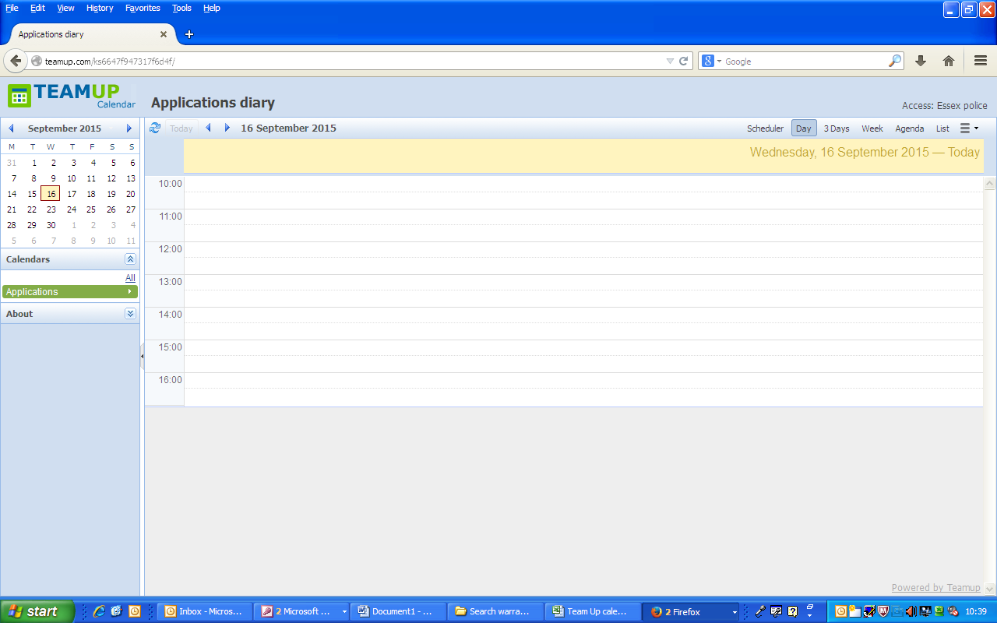

This shows you are logged in under your police authority.

Either use the arrows or click on the desired date.

You can change your view of the calendar by clicking on ‘3 days’ or ‘week’.

Either use the arrows or click on the desired date

The calendar will default to todays date.

There are 17 search warrants slots available for booking each day, each slot to be booked for 15mins. Due to the size of the text when two slots are booked in one hour it may appear full however there are 3 slots available each hour, the below image shows how a completely fully booked calendar appears

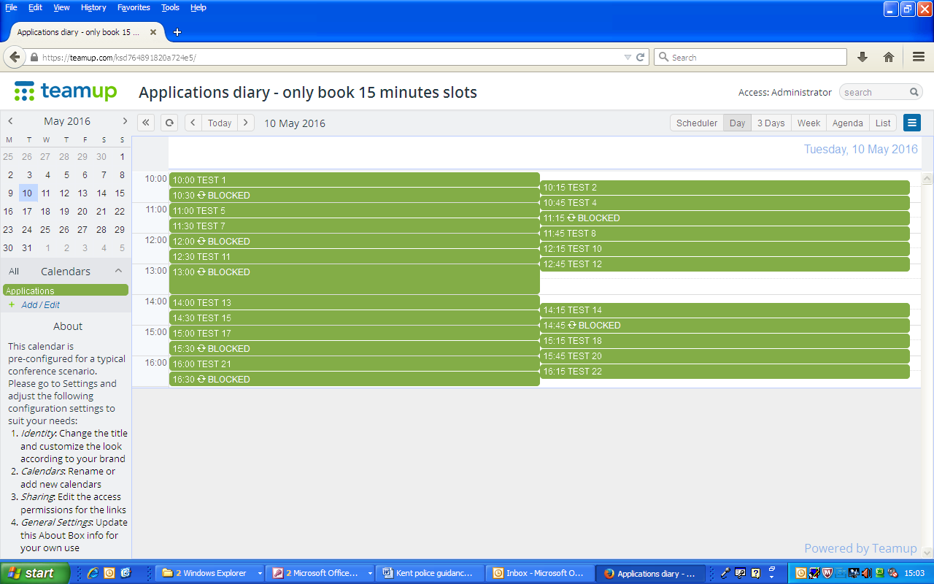

* The first slot each day is 10:00.
* The last slot each day is 16:15.
* There will be no bookings allowed between 13:00 and 14:00.
* There are 5 additional blocked slots throughout the day, these are to allow the legal adviser to keep to time, they can be unblocked by HMCTS if required.
* For assistance with selecting which application number relates to which time please see page 14
* On Thursdays there are two legal teams hearing applications. Therefore bookings can be made on two calendars on Thursdays only. Do not book on the extra slots calendar on any other day as your application will not be heard.
* When booking on a Thursday the Team Up calendar will look like this:

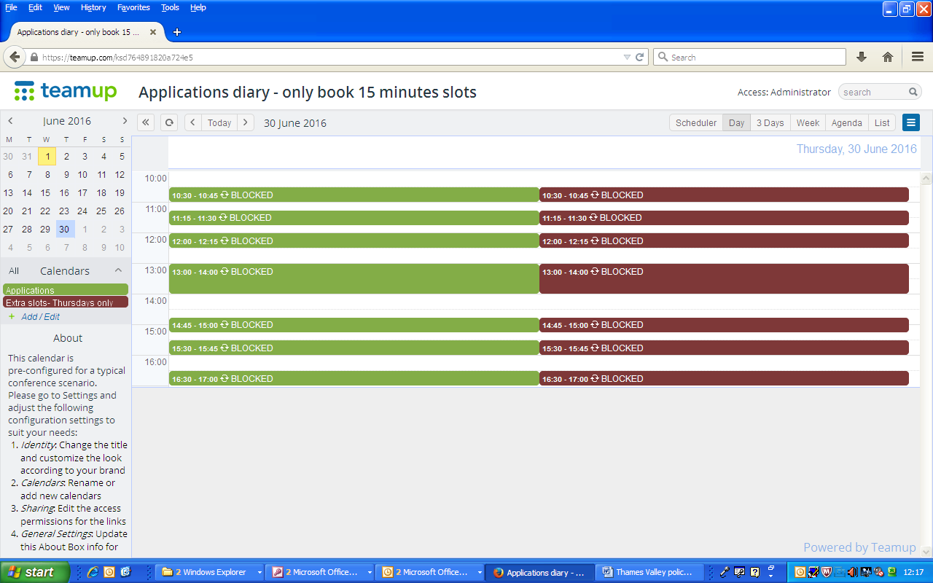

Do not use the ‘Extra slots’ calendar on any day other than a Thursday.

Do not use the ‘Extra slots’ calendar on any day other than a Thursday.

* To book, select the time as usual however you have the option to book on the green or red calendar.

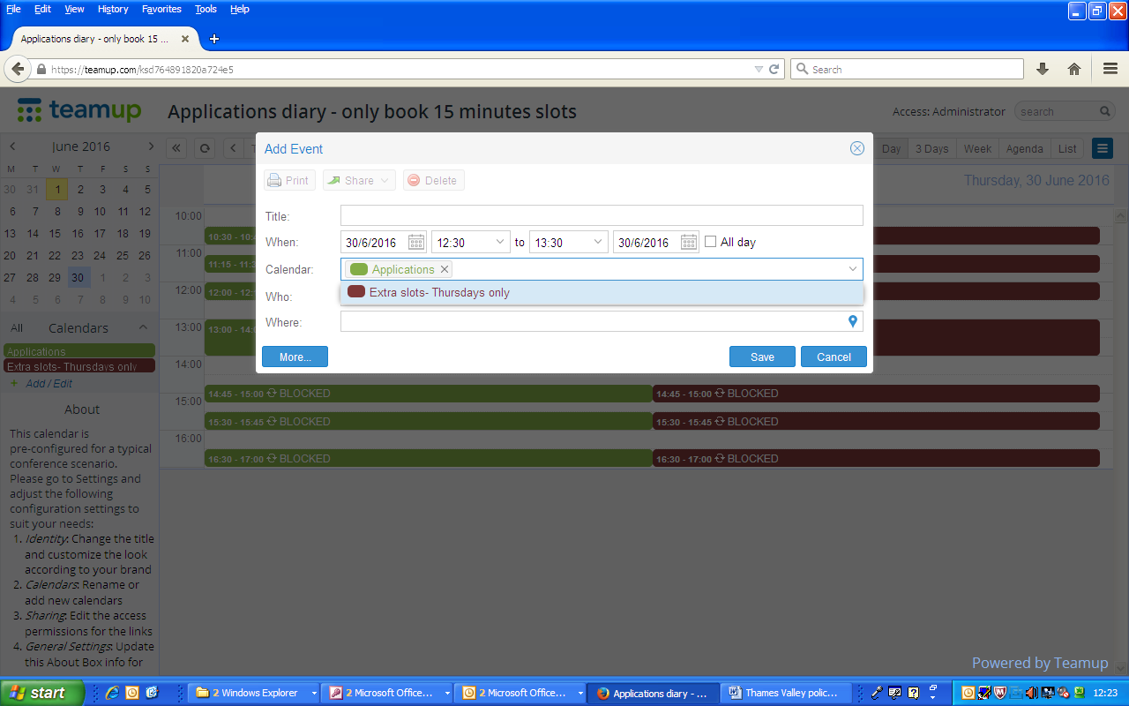

Click on the arrow to make your selection.

Ensure only one of the calendars is selected or your booking will be duplicated.

To book a slot, click on the calendar and the following box will appear:

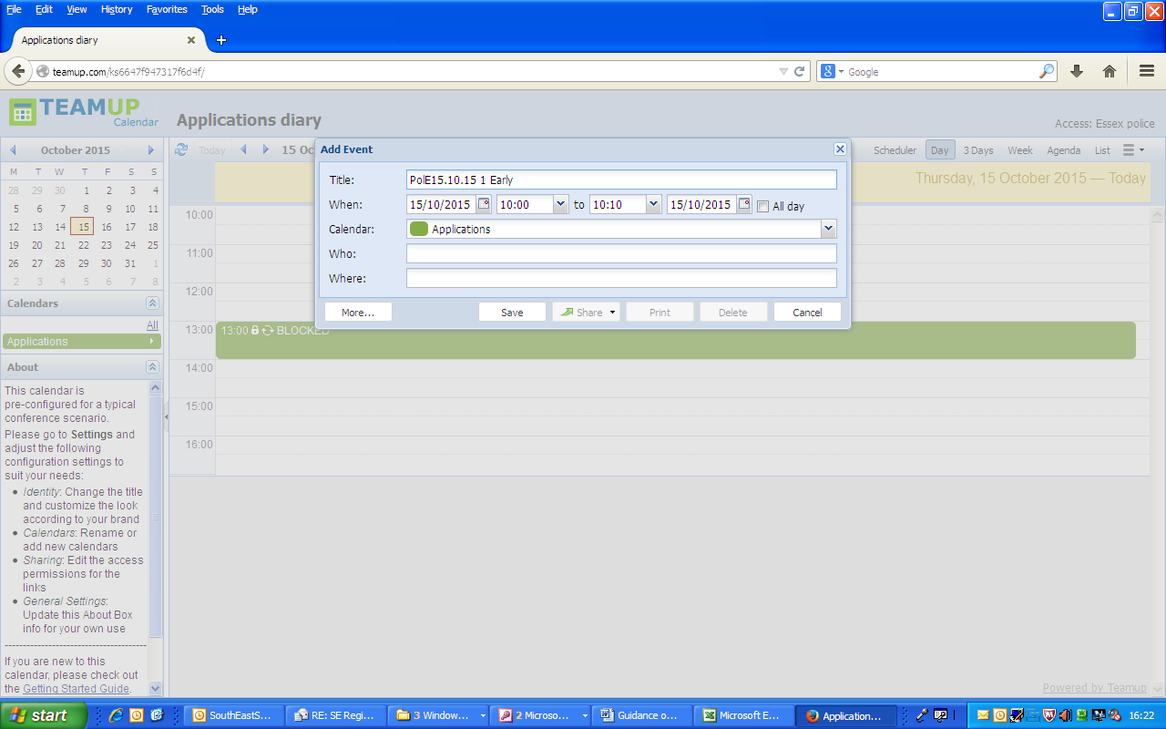

Change the booking time to the time you want to book, you will need to amend the slot to be only 15mins long.

To save the booking click save.

Type in the correct naming convection. This must be used or it may result in the booking being deleted by the administrator.

Naming convention:

The code of your agency; Date the application is to be heard; Application number of the day i.e. the first app at 10am will be 1, the 2nd 2 etc; Surname of Officer

i.e. MH15.10.151EARLY

Ensure the date is the correct date.

* Use the following code in the naming convention.

Mental Health agencies: MH

* It is imperative to put the dots in the date i.e. 16.10.15 – this is the date the application is to be heard.
* The calendar does not allow for overlapped bookings, therefore if you try to book a slot that has already been booked you will see the following error message:

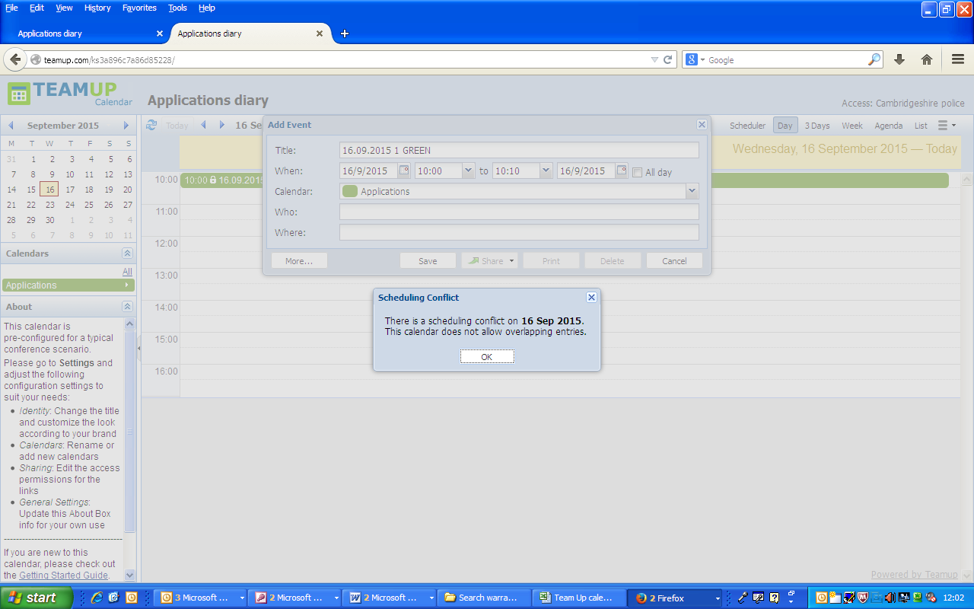

* Click ok to remove the message and then reselect another time slot.
* The calendar will allow for multiple users to be logged in at the same time using the same link, therefore it is possible that 2 officers may be trying to book the same slot- if this occurs you will receive the same error message as above.
* Each warrant must have a separate booking with a separate name following the naming convention.
* Each application must have the same name as the warrant paperwork.
* Where an application is for specified multiple premises warrants, time slots should be booked for each premises, for example 1 application for 3 premises could be booked in at 14:00, 14:15 and 14:30.
* For ‘All premises’ warrants only 1 slot needs to be booked.
* If more than 6 are warrants are being applied for at the same time, supported by one application you should ring the emergency administrator number before booking in. The administrator will then liaise with the legal adviser to best advise how the applications can be heard.
* To delete a booking, click on the booking you wish to cancel.

A locked symbol means it has been booked by another police authority and you are unable to amend the booking.

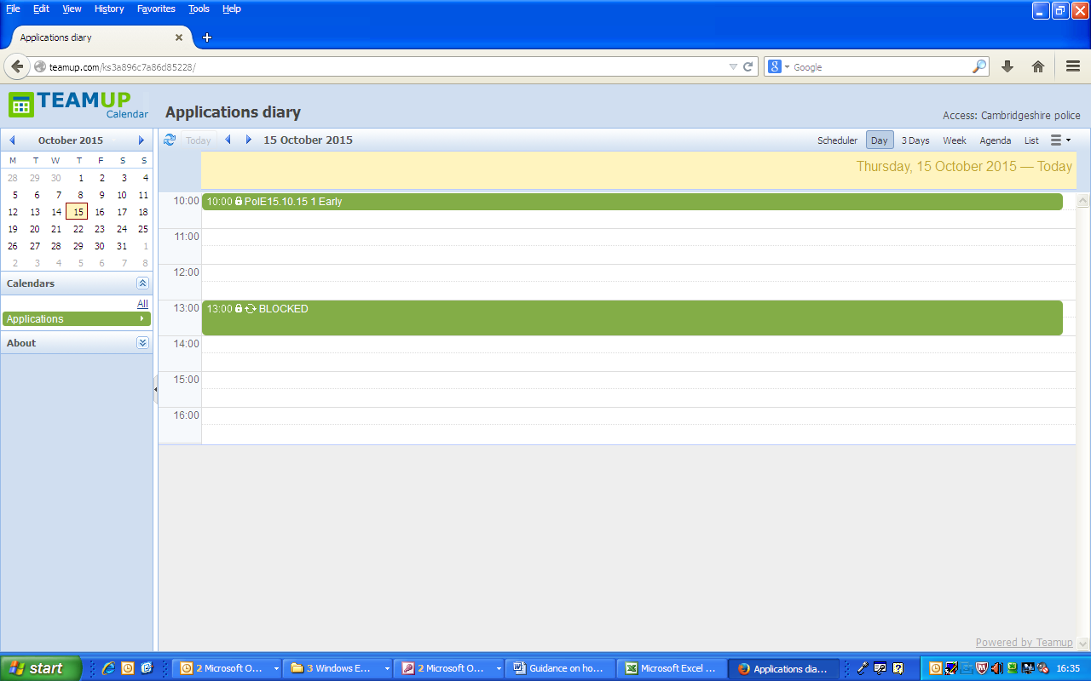

* Clicking on booking that you are able to amend will bring up the following box:

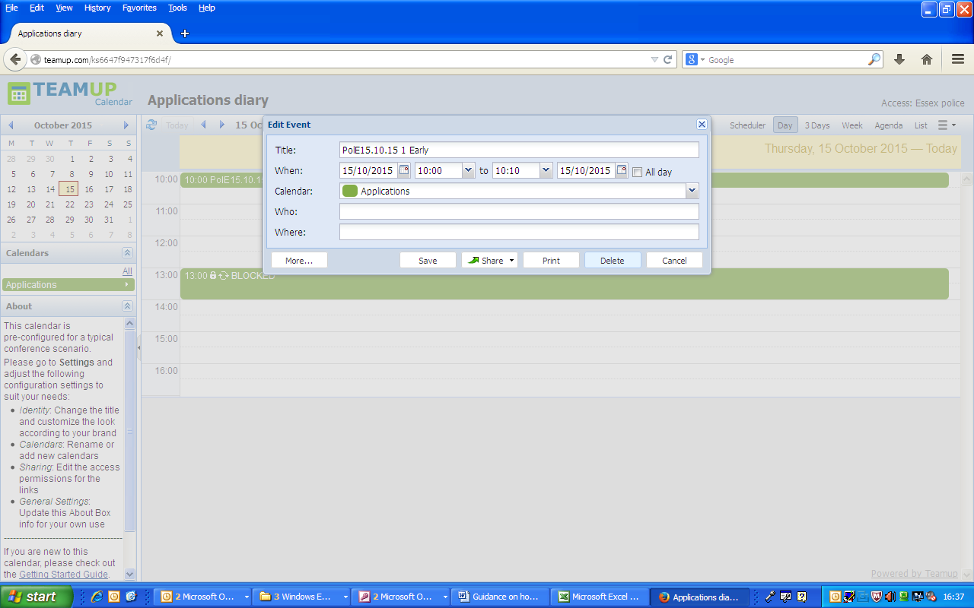

To delete click here.

* If you click on a booking that has been made by another police authority you will see a box displaying the booking information.

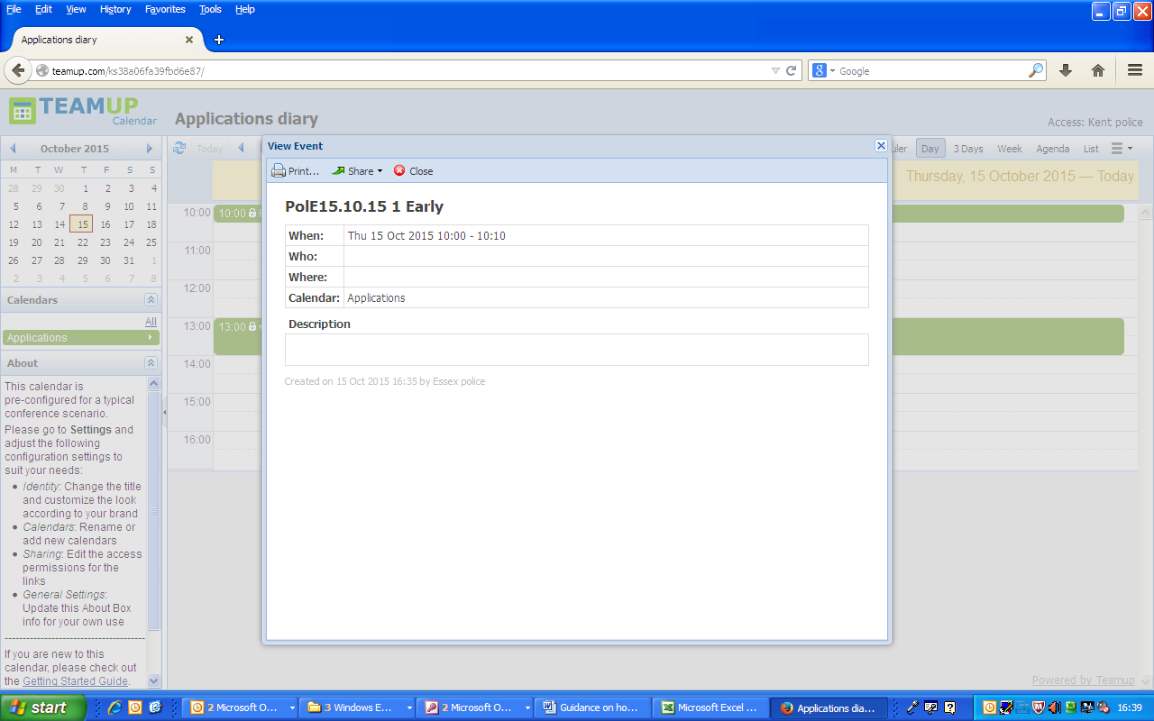

* A copy of the application and the warrant will need to be emailed through to [SouthEastSearchWar@hmcts.gsi.gov.uk](mailto:SouthEastSearchWar@hmcts.gsi.gov.uk) at the time of booking, using the same naming convention used when booking the application i.e. MH16.09.15 1 EARLY. This application code is to be added to the top of the application and warrant documents as shown in red on the below example.

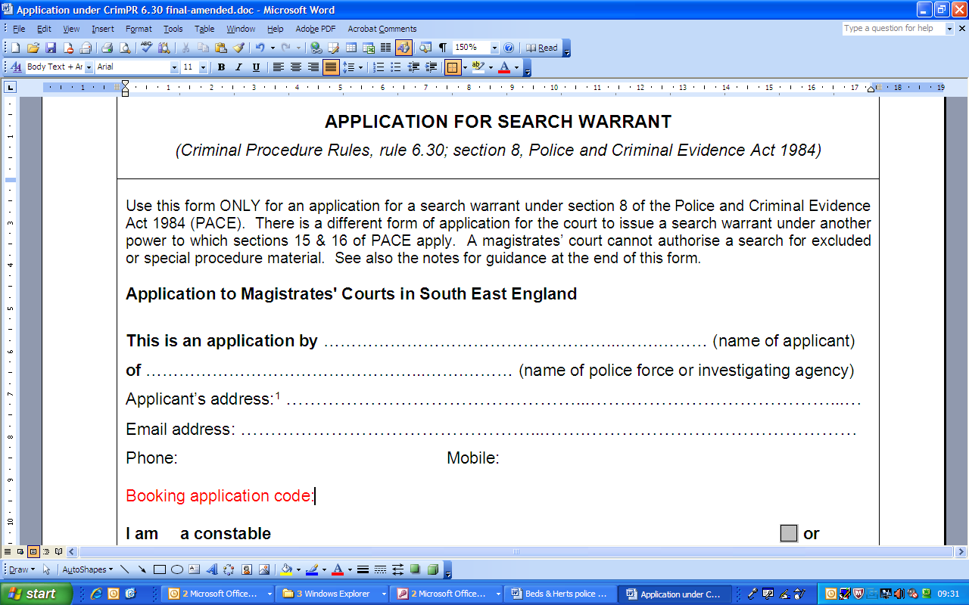

Application number according to time

|  |  |  |  |
| --- | --- | --- | --- |
| 10:00 | **1** | 12.45 | **12** |
| 10:15 | **2** | 14:00 | **13** |
| 10:30 | **3** | 14:15 | **14** |
| 10:45 | **4** | 14:30 | **15** |
| 11:00 | **5** | 14:45 | **16** |
| 11:15 | **6** | 15:00 | **17** |
| 11:30 | **7** | 15:15 | **18** |
| 11:45 | **8** | 15:30 | **19** |
| 12:00 | **9** | 15:45 | **20** |
| 12:15 | **10** | 16:00 | **21** |
| 12:30 | **11** | 16:15 | **22** |

Copies of warrants and applications

