**ALLERGENS: RECIPE CARD**

Dish: ____________________________________________________________

Date: ____________________________ Chef: _________________________

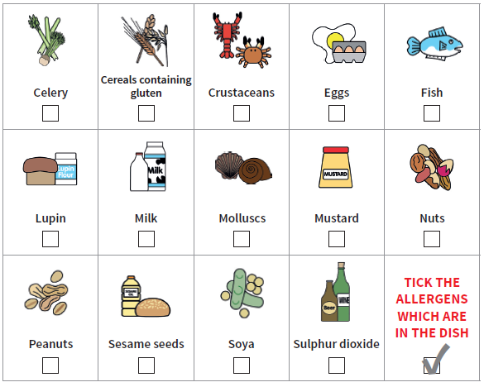

Notes:

|  |
| --- |
|  |
|  |
|  |
|  |
|  |
|  |
|  |

Reviewed and checked by: ­­­­­­­­­­­­­­­­______________________________________